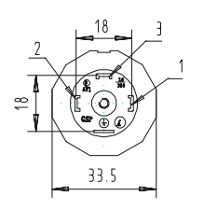
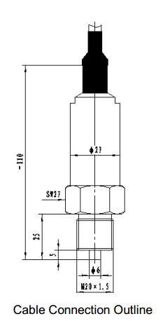
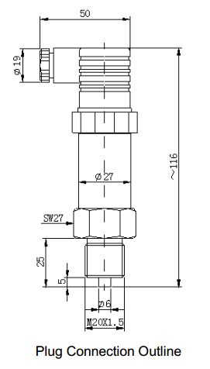
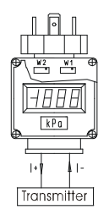
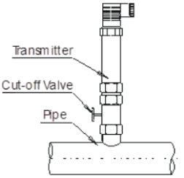
chart 1:The electric definitions of cable are as follow：
Cable | 2-wire | 3-wire
Black | +V | +V
Red | +OUT | +OUT
Blue | Null | GND

Specification
Range | -0.1Mpa▪▪▪0MPa～0.01MPa▪▪▪100MPa
Overpressure | 2 times FS or 110MPa (min. value is valid)
Pressure type | gauge/ absolute / sealed gauge
Process connection | M20×1.5 male waterline seal (or on your demand)
Accuracy | ±0.25％FS
Long term stability | max. ±0.3%FS/year
Zero thermal drift | ±0.1%FS/℃(≤100kPa)；±0.05%FS/℃(＞100kPa)
Span thermal drift | ±0.1%FS/℃(≤100kPa)；±0.05%FS/℃(＜100kPa)
Compensation temp. | -10℃-80℃
Application temp. | -30℃～80℃
Storage temp. | -55℃～150℃
Power supply | 11~28V DC
Output signal | 4mA～20mADC（2-wire）， 0/1V～5VDC（3-wire）
Load | ≤（U-10）/0.02Ω（2-wire）， ≥10K（3-wire）
Housing protection | IP65
Electric connection | DIN43650 plug or cable connection
Housing | Stainless Steel 1Cr18Ni9Ti
O-Ring | Viton
Cable | Φ7.5mm Polyethylene Special Cable
Plug Housing | Plastic

Water Technology Systems

720E Piezo-resistive
Pressure Transmitter
v1.1.1

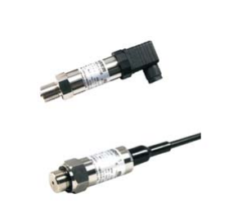
Introduction
This product uses high stable and reliable pressure sensor and special circuit board to produce transmitter, and performance is good and reliable.
720E pressure transmitter is used for measure and control of petroleum, chemi-industry, electric power, hydrology and flow pressure measure, etc.

Feature
·Reliable performance, easy application
·Short protection and reverse polarity protection
·Measure gauge, absolute and sealed gauge
·RoHS approved
Construction and Mounting Dimension

Electric Connection
The transmitter is connected with the outside circuit through plug or special cable.
The pin arrangements of socket are to see chart 1, and pin definitions are as follows：

Pin | 2-wire | 3-wire
1 | +V | +V
2 | +OUT | GND
3 | Null | +OUT

Pin | 4-wire
1 | +V
2 | -V
3 | 485A
4 | 485B
Unpacking, Storage and Shipment Enclosed
Unpacking caution:
(1) Be sure the package is completed, and the package should be put as the sign “UP”.
(2) Be sure unpacking carefully, and prevent damaging instruments or accessories. Pay attention to the housing jacket and rubber bushing of transmitter cable.

Enclosed:
The transmitter should be enclosed when out of factory:
720E Piezo-resistive Pressure Transmitter 1
Production Qualification Certificate 1
User Manual 1
Storage:
The transmitter should be stored in dry ventilate room, ambient temperature -55℃～150℃ and the relative humidity≤85%, no corrosive substance in the room.
Installation
Check before Installation
Please be sure before Installation:
(1) The measuring pressure is in the measurement range.
(2)The measuring medium is compatible with construction.
(3)The measuring medium would not jam the pressure-leading hole.
Installation Method:
Usually the transmitter should be mounted vertically up to the horizontal direction. If the condition is unavailable, the allowed max. mount slope angle from transmitter to the horizontal direction is 30 degree. It is not recommended to mount the transmitter invertedly.
The pressure port of the transmitter is male with waterline seal, could be mounted on the port of
the measurement pipe.To be convenient for installation and repair, cut-off valve should be mounted between transmitter port and pipe.
Caution:do not poke the pressure-leading hole with metal wire or something hard; and do not press the diaphragm with finger or something sharp to protect the diaphragm.
The recommended method is to see chart 2.

chart 2

The transmitter could work at once as soon as the power is supplied. But the signal output will be more stable after 30 minutes.
Maintenance：
720E Piezo-resistive pressure transmitter is the compact measurement device, please pay attention to the following items in the operation:
(1) If the pressure-leading hole is jammed or the diaphragm is dirty, please clean them with impregnant which is compatible with transmitter construction material. Do not poke pressure-leading hole with hard object or brush diaphragm.
(2)Other cable in the transmitter is for our company’s adjustments, do not connect it at will to protect the transmitter.
(3)After electric connection, make sure to screw down the socket screw-cap and cable-fixed nut.
Responsibility：
Within 2 years from the delivery date, we shall repair or replace the instrument with any quality fault caused by material parts or our manufacturing technique free of charge. For non-quality malfunction during user’s operation, we are in charge of repair. But the material cost and the shuttle transportation fees should be borne by users.

Requirement description and improvement：

Water Technology Systems

Indicator Operation
Indicator Adjustment
1.Open the front panel of indicator
as chart 3（take LED indicator as
example, LCD indicator is similar）.
2. Input 4mA（±0.05%）into indic-
ator show “000”;
3. Then input 20mA（±0.05%）into
indicator, show the required value. chart 3
Note：the indicator is 2-wire, and should be connected serially with 4～20mADC circuit when operating or adjusting.
The Connection between Indicator and Transmitter：
1. The selected indicator could only be connected serially to the plug connection transmitter with 2-wire, 4~20mA output.
2. Indicator Installation
(1)The indicator electric interface is compatible with plug and transmitter socket interfaces. Four jacks could match four pins.
(2)Mount the matched rectangle-ring to the indicator jack side, and then connect the indicator jacks with transmitter socket pins.
(3) Turn-on the fixed nut on the indicator pins side and take out the core. A cross bolt could be seen. Screw down the bolt with cross screwdriver and put in the core. Then screw down the fixed nut. Caution: take out or put in slightly lest snap the cable; there is an O-ring on the core, be sure the O-ring the same as the pre-mounting situation.
(4) Mount the rectangle-ring on the plug, and match the plug to the indicator pins side. Then screw down the central bolt on the top of the plug. Be sure the rectangle-ring is mounted suitably and correctly during the operation.

Operation, Maintenance and Responsibility
Operation：
The user could operate the transmitter without any adjustment. Be sure the installation and electric connection are correct.

