522 Portable Hydraulic Pressure Pump
Operation Manual

1. Product Overview
The 522 Portable Hydraulic Pressure Pump is a manual pressure source designed for calibration and testing of pressure measuring instruments. It features a compact structure, convenient operation, stable pressure output, and is suitable for field calibration applications.

2. Technical Specifications
- Pressure Range: -0.08~60 MPa
- Pressure Medium: Transformer oil or clean water
- Minimum Adjustable Resolution: 10 kPa
- Connection Thread: M20×1.5
- Dimensions: 345 × 225 × 150 mm
- Weight: Approx. 4 kg
- Operating Temperature: 0~50℃
- Operating Humidity: <85%

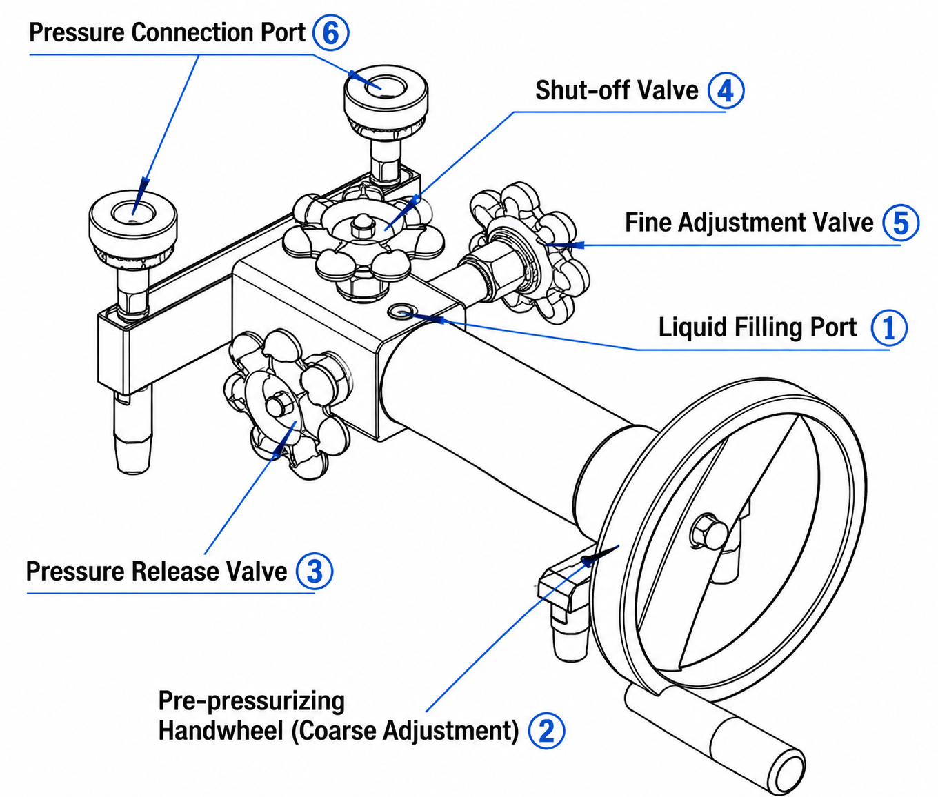

3. Main Components
- Liquid Filling Port
- Pre-pressurizing Handwheel (Coarse Adjustment)
- Pressure Release Valve
- Shut-off Valve
- Fine Adjustment Valve (Pressure Increase)
- Pressure Instrument Connection Port

4. Operating Instructions

4.1 Preparation
Before use, open the liquid filling port and fill with clean transformer oil, hydraulic oil, or pure water. During operation, keep the filling port slightly loosened to maintain ventilation.

4.2 Pressure Calibration Procedure
1. Connect the standard pressure instrument and the instrument under test.
2. Perform air removal by operating the pre-pressurizing handwheel.
3. Close the release valve and adjust pressure gradually using the fine adjustment valve.
4. Compare readings at each calibration point and record the results.

4.3 Pressure Reduction Calibration
Slowly rotate the fine adjustment valve to reduce pressure. Compare and record the readings at each calibration point during the pressure decreasing process.

4.4 Zero Point Calibration
Open the pressure release valve and shut-off valve to perform zero point verification.

4.5 Vacuum Calibration
Adjust the pre-pressurizing handwheel and fine adjustment valve to the required position, then operate gradually to achieve the required negative pressure point.

5. Safety Precautions
- Use the hydraulic pump within the rated pressure range. Do not exceed the maximum safe pressure of 80 MPa.
- When transporting or carrying the pump, lock the quick connector with plugs and fully tighten adjustment handwheels.
- Keep the liquid filling port open during operation.
- Do not apply excessive force to valves, knobs, handles, or connectors.
- Replace the pressure medium if it becomes contaminated.
- Keep exposed threaded parts clean and lubricated.

6. Application
The 522 Portable Hydraulic Pressure Pump is widely used for calibration, testing, and maintenance of pressure gauges, pressure transmitters, and other pressure instruments in industrial applications.

